Igniter (Abstracted)

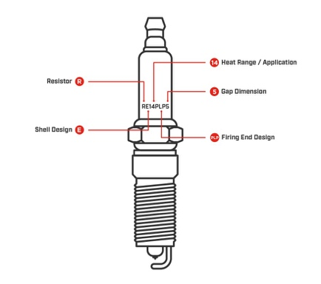Spark Plug